**1. Xamarin Workshop Installation Guide**  
**Installation**  
**A. Requirement**  
1. Windows 10 Pro and above  
2. Visual Studio 2017 (<https://visualstudio.microsoft.com/>)  
3. Windows 10 SDK (<https://developer.microsoft.com/en-us/windows/downloads/windows-10-sdk>)

**B. Accelerating with HAXM**  
Steps to download and install HAXM  
1. From the Intel website, download the latest HAXM virtualization engine (<https://software.intel.com/en-us/articles/intel-hardware-accelerated-execution-manager-intel-haxm> ) installer for Windows. The advantage of downloading the HAXM installer directly from the Intel website is that you can be assured of using the latest version.  
2. Run **intelhaxm-andorid.exe** to start the HAXM installer. Accept the default values in the installer dialogs:  
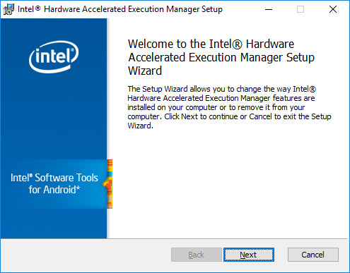

**C. Accelerating with Hyper-V**  
Steps to accelerate the Android Emulator with Hyper-V  
1. Enter **windows features** in the Windows search box and select **Turn Windows features on or off** in the search results.  
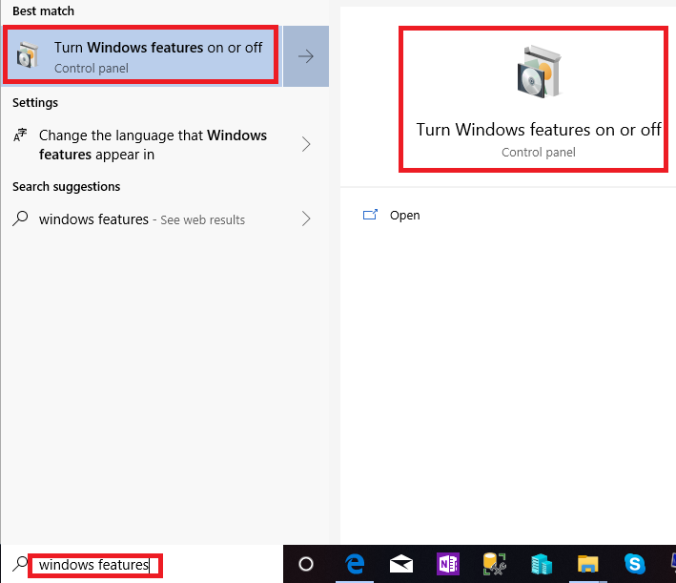

In the Windows features dialog, enable both **Hyper-V** and **Windows Hypervisor Platform**.  
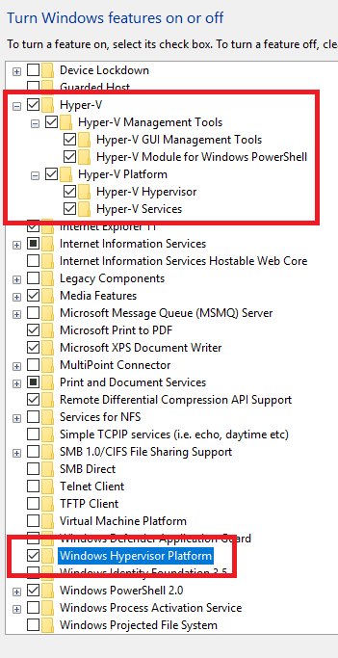  
**After making these changes, reboot your computer.**

**D. Installing Xamarin on Windows**  
Step-by-step instructions  
Xamarin can be installed as party on a new Visual Studio 2017 installation, with the following steps:  
1. Download Visual Studio 2017 Community, Visual Studio Professional, or Visual Studio Enterprise from the Visual Studio (<https://visualstudio.microsoft.com/>) page.  
2. Double-click the downloaded package to start installation.  
3. Select the **Mobile development with .NET** workload from the installation screen:  
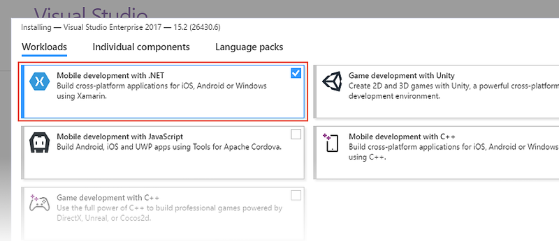

4. While **Mobile development with .NET** is selected, have a look at the **Installation details** panel on the right. Here, you can deselect mobile development options that you do not want to install.  
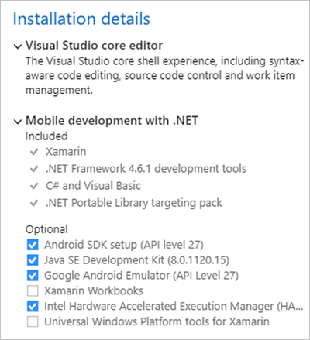

5. When you are ready to begin Visual Studio 2017 installation, click the **Install** button in the lower right-hand corner:  
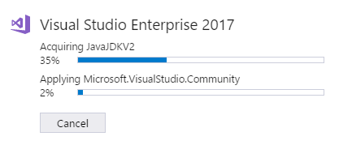

6. When Visual Studio 2017 installation has completed, click the **Launch** button to start Visual Studio:  
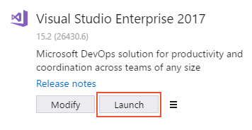

7. **Install the Android Emulator package 27.2.7** or later. To install this package, navigate to **Tools > Android > Android SDK Manager** in Visual Studio.  
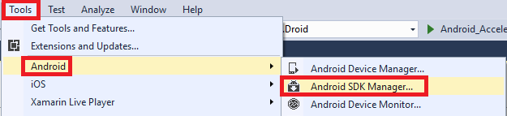

8. Select the Tools tab and ensure that the Android emulator version is at least 27.2.7. Also ensure that the Android SDK Tools version is 2.1.1 or later.  
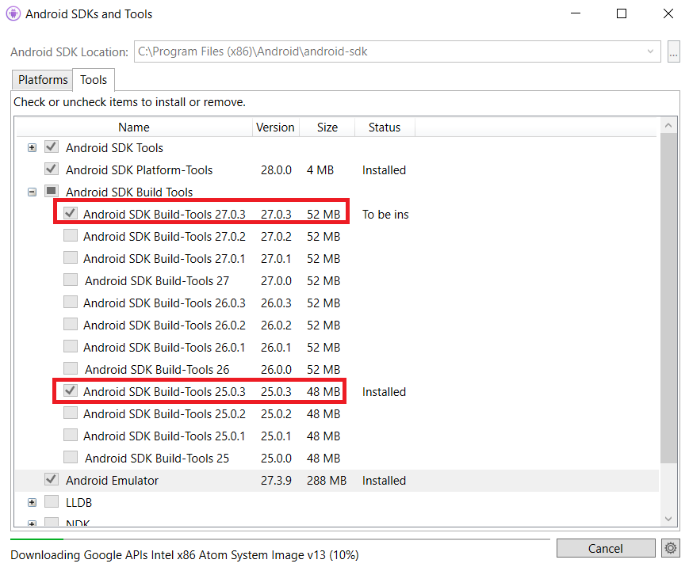

9. Go to **Home** > **For developers** > select **Developer mode**  
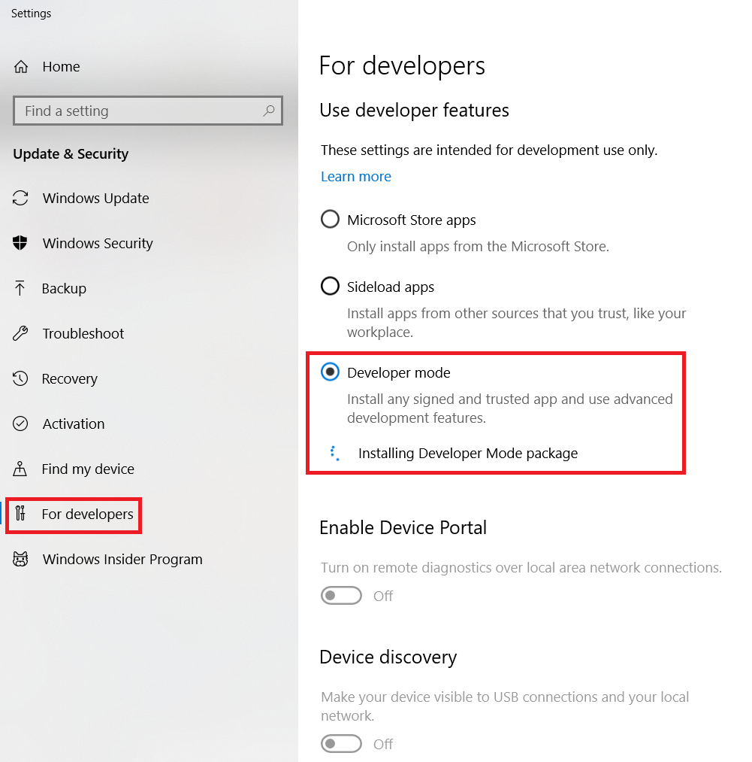

**2. Validate your development environment**  
**Steps  
Open the Solution in Visual Studio on Windows**1. Open the **TaskyPro.sln** solution contained in the **Exercise 1/ TaskyPro** (<https://1drv.ms/f/s!ArrrFEp9JrXBjdAeYJ1jpHYf6j8y9Q> ) folder. This solution contains several projects, take a moment to familiarize yourself with each one.

|  |  |
| --- | --- |
| **Project** | **Description** |
| Tasky.Core | This is a Portable Class Library which contains the code that is shared across all the platforms (iOS, Android and Windows). The code is written in C# and is where the business logic and data models used in the application are stored. |
| Tasky.Droid | This is the Xamarin.Android project which can be deployed onto an Android device or emulator. Use this project to test your Android setup/ |
| Tasky.iOS | This is the Xamarin.iOS project which can be deployed onto an iOS device or simulator. Use this project to text your iOS setup. |

2. Select which version (iOS or Android) you want to run by **right-clicking** on the project and selecting **Set as Startup Project** from the context menu. The startup project is always shown in **Bold** text in the Solution Explorer.  
3. Set the **Build Configuration** to be **Debug** and select a simulator or emulator from the drop down in the Toolbar.  
4. Build and run the application by clicking the **Play** button in the Toolbar.  
5. The application should launch and display and empty task list. You can add new tasks through the (+) button, and tap on entered tasks to display details.  
6. Repeat the same steps for the other environments(s) you want to test on – change the startup project, build and run the application.  
  
**NOTE:**   
1. If you get the following screenshot, click on **OK** button.  
